**MTN-017**

**SMS 101**

**Sample Training Guide**

*For more precision, please refer to the User’s Guide that comes with your phone.*

**To Save a Contact in the Address Book**   
*NOTE: Contacts can also be saved from the [call history log](http://www.att.com/esupport/article.jsp?sid=KB410445" \t "_self).*

1. From the standby screen,

Dial the desired number, then select **Options**.

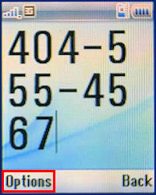

2. Select **Save Number.**

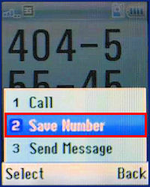

3. Select the desired option for saving.  
NOTE: In this example, we will **Create Contact**.

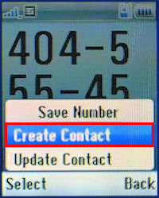

4. Enter the Contact Details, then select **Save**.

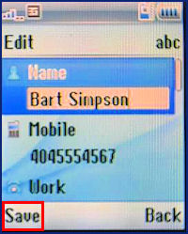

**To Send an SMS**

1. From the standby screen, press **Menu**.

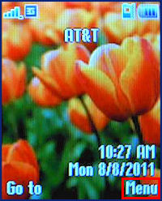

2. Select **Messaging**.by clicking until the little envelope is highlighted

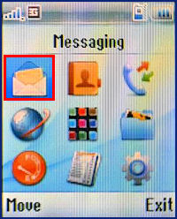

3. Select **Create Message.**

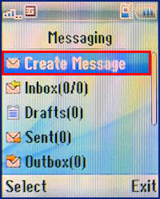

**To send to a recipient not in the Address Book**

Manually enter the number to send to**.**

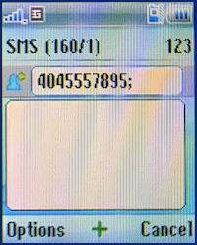

Use the mandatory 10-digit pattern (Example: "4075551212").

**To send an SMS to a recipient stored in the Address Book**

1. Select the **+** icon to add contacts from the Address Book**.**   

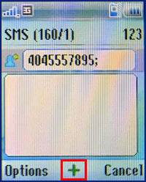

2. Highlight the desired recipient(s), then select **Check.**  

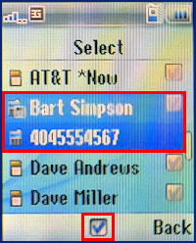

3. Once all desired recipients are **Checked**, select **Done.**  

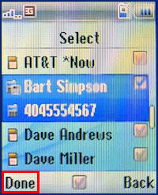

4. Enter the desired Text for the message, then select the **Send** icon (green arrow).

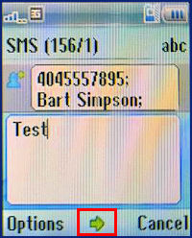

**To Receive an SMS**

1. To read a message when it first arrives:

Select **View.** The message will be displayed. Select **Off** to dismiss the notification.

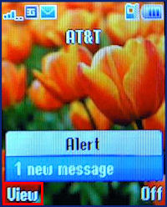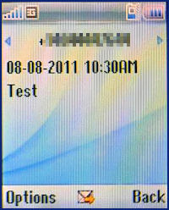

2. To read a message later:

From the standby screen, press **Menu.**

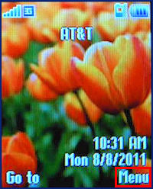

3. Select **Messaging** by clicking until the little envelope is highlighted.

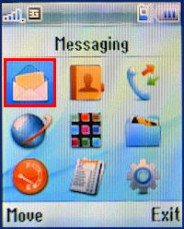

4. Select **Inbox**.

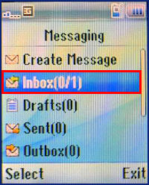

5. Select the desired Message.

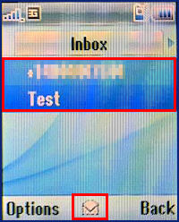

6. The message will be displayed.



**To Delete an SMS**

1. From the standby screen, select **Menu**.



2. Select **Messaging** by clicking until the little envelope is highlighted.



3. Select **Inbox**.



4. Select the desired Message.



5. Select **Options**.

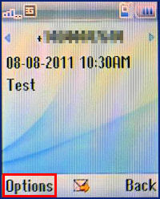

6. Select **Delete.**

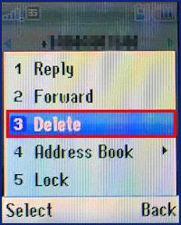

7. Select **Yes** to confirm deletion.

